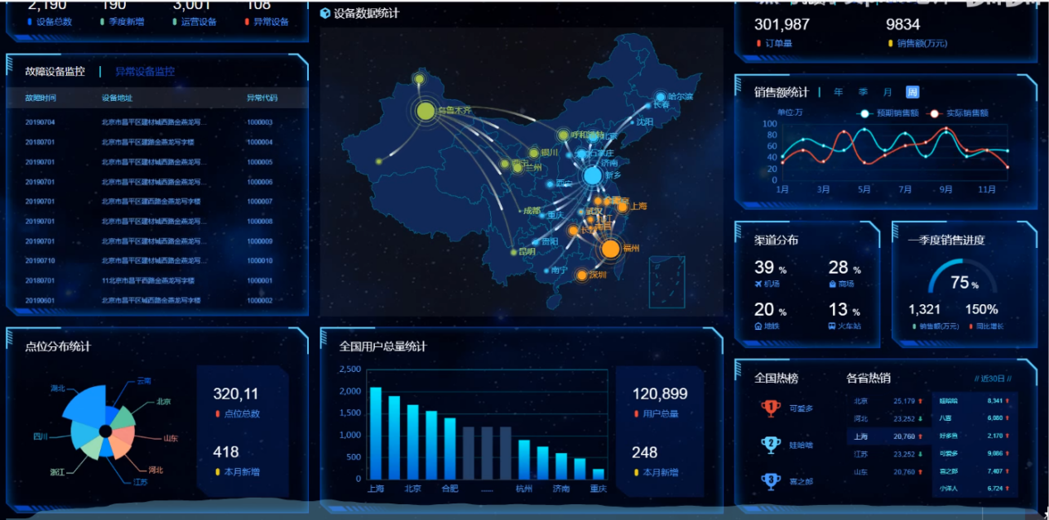

[可视化](https://gitee.com/zhoushugang/zhoushugang)